Exercise 1: Installation of VirtualBox and Creation of Virtual Machines

Aim
To install Oracle VM VirtualBox and create a virtual machine with a different operating system flavor (Ubuntu).

Prerequisites
- Windows 10 Host Machine
- Oracle VM VirtualBox (Open Source)
- Ubuntu Desktop ISO image (Open Source)

Procedure

Step 1: Download Oracle VM VirtualBox
Navigate to virtualbox.org and download the Windows hosts installer. Run the installer using default settings.
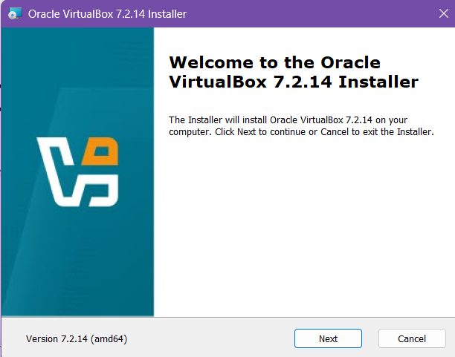
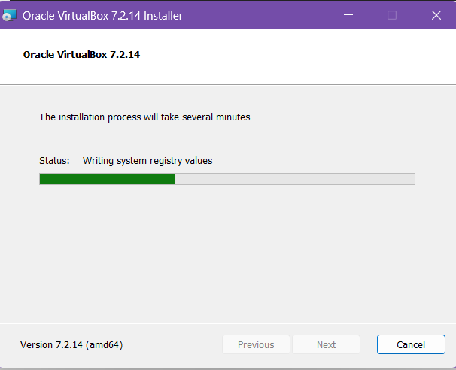

Step 2: Download Linux Image
Download the latest Ubuntu LTS (.iso) from ubuntu.com/download/desktop.

Step 3: Create a New Virtual Machine
Open VirtualBox and click "New".
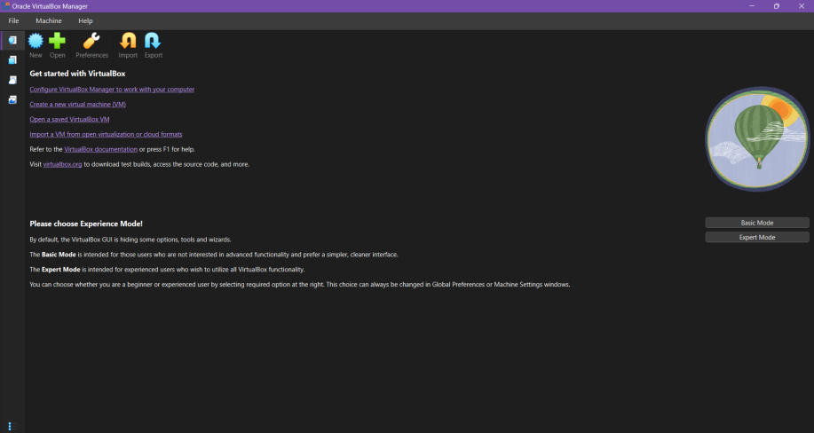
Name: "Ubuntu-Lab", Type: Linux, Version: Ubuntu (64-bit). Select the path of the Ubuntu ISO image.
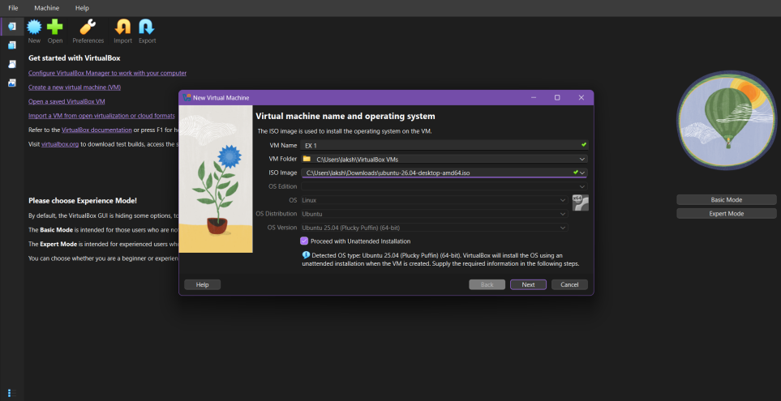
Allocate Memory (RAM): minimum 4096 MB (4GB). Create a Virtual Hard Disk: VDI format, Dynamically allocated, minimum 25GB. Click Finish.
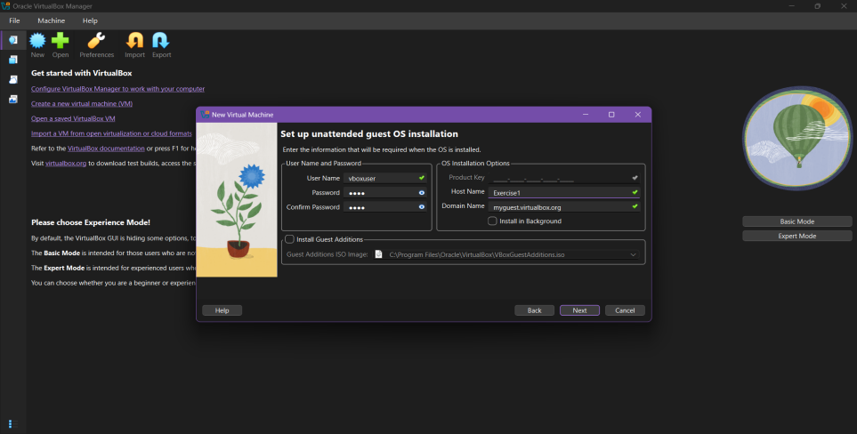

Step 4: Mount the ISO and Boot
- Select the VM -> Settings -> Storage.
- Click the empty optical drive icon and choose the downloaded Ubuntu .iso file.
- Click "Start" to boot the VM.
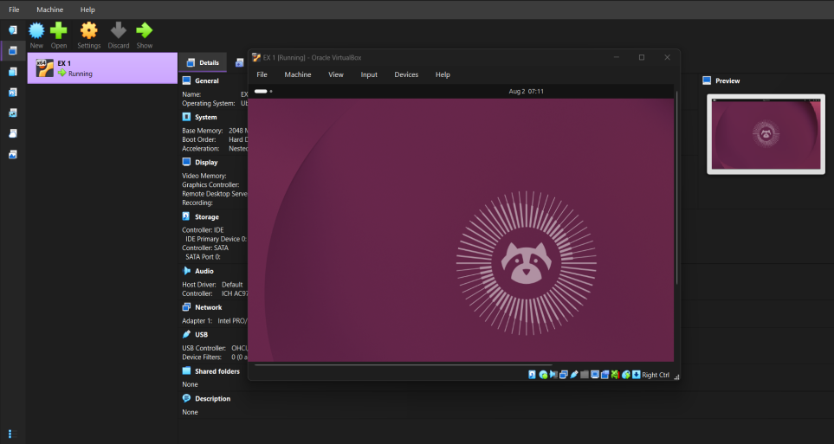

Step 5: Install Ubuntu
Follow the on-screen Ubuntu installer. Select "Install Ubuntu", choose keyboard layout, and wait for the installation to complete. Restart the VM when prompted.

Result
Thus, Oracle VM VirtualBox was successfully installed and a virtual machine running Ubuntu was created and booted.

